Tab 1
Supplementary Information

S1. U.S. Geological Survey Publication Warehouse Literature Search 2
S2. Literature and Data Review of U.S. Geological Survey Documents 4
S3. Metadata extraction with Large Language Models (LLMs) 6
S4. Comparison of human vs LLM categorization 7
S5. 8

S1. U.S. Geological Survey Publication Warehouse Literature Search
A literature search of the U.S. Geological Survey (USGS) Publications Warehouse was conducted in three phases to compile documents containing water data. Geographic filtering for California documents was completed manually due to constraints in the USGS Publications Warehouse filtering functions. This involved incorporating the location name directly within the search criteria or manually filtering relevant documents by checking for location references in the title or metadata description. For all numbers reported here, the number of extracted documents does not equate to the number of documents processed, as many were not available digitally online (scanned PDF).

Literature Search 1:

The first literature search targeted documents across the United States containing water-related terms (Table X) with a date constraint of being published on or before 1970 (1879-1970). This search, conducted on June 5, 2024, resulted in 7,547 documents. California-specific documents were then extracted by applying a filter function for the term “California” within the extracted United States file. This was completed on July 12 and resulted in a total of 550 documents for California. For Santa Barbara, a focused search using the criteria term “Santa Barbara" and the same publication date constraint (1879-1970) was conducted on July 2, 2024 and resulted in a total of 58 papers.

Literature Search 2:
The period of analysis was extended to include publications through 1980 (1879-1980). To encompass this additional decade, a search for the United States was completed using the same water related terms (Table X) with two time constraints of “Published starting in 1970” and “Published in or before 1980” on July 30, 2024. This resulted in an additional 6,538 documents. California documents were filtered from this list, also on July 30, 2024.

Literature Search 3:
Santa Barbara, California, was identified as a region of interest, and a literature search to identify documents within Santa Barbara County was conducted on July 31, 2024, by using the search criteria “Santa Barbara” and the two time constraints of “Published starting in 1970” and “Published in or before 1980”. This resulted in an additional 27 papers, for a total of 85 papers.

Water related terms

To begin the data extraction process, a set of key water related terms was identified to serve as the search criteria within the USGS Publications Warehouse. A comprehensive list of 27 water related terms was compiled, constituting various hydrologic categories. The terms used are outlined in the table below.

Table X. Water related terms used in the USGS Publications Warehouse literature search.
Groundwater Related Terms | Precipitation Related Terms | Stream Related Terms | Spring Related Terms | Water Supply
Wells | Precipitation | Stream | Spring | Water-supply
Borings | Rain | Streams | Springs | Irrigation
Underground | Rainfall | Discharge |  | Water-right
Waters | Weather | River |  | Water allocation
Water | Snow | Rivers
Groundwater |  | Flow
Ground-water |  | Creek
Artesian
Flowing

S2. Literature and Data Review of U.S. Geological Survey Documents
Figure Draft
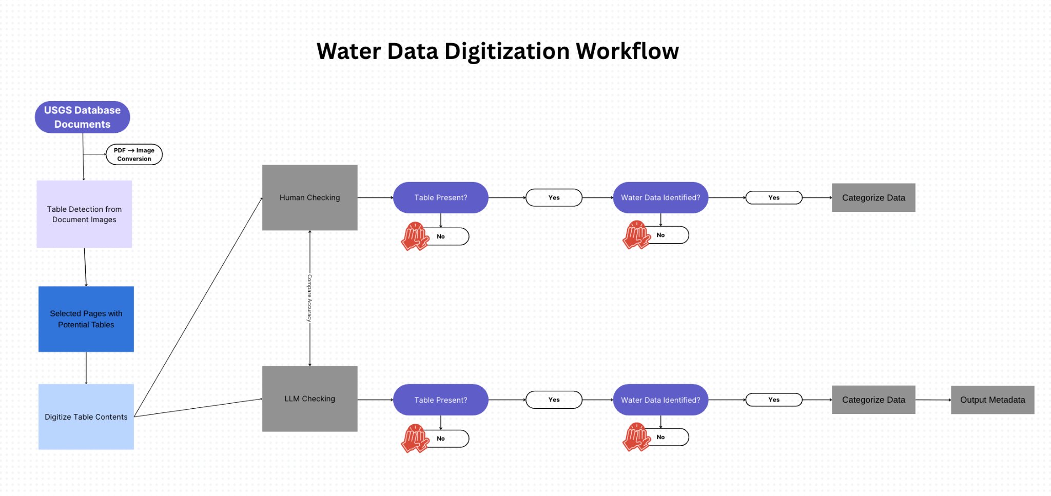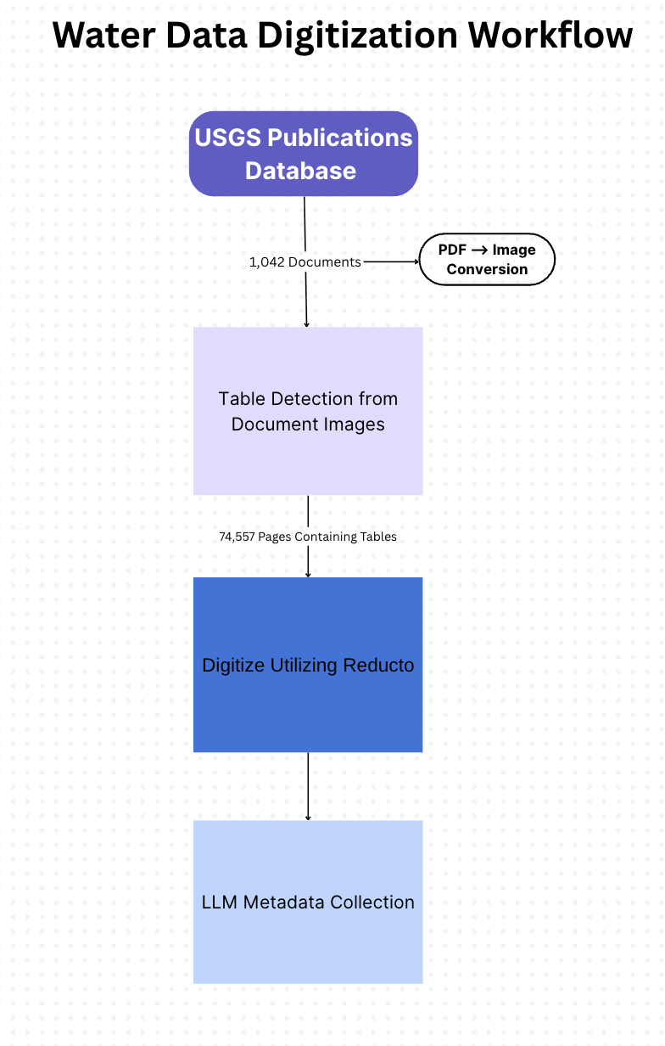
Table Detection
The first step in the data digitization process involved using a table detection algorithm to scan the USGS Publications Warehouse documents and identify tables. During this process, each PDF page was converted to an image, allowing the algorithm to analyze the content of every page and flag those containing tables.
To improve table detection accuracy, a human checking component was integrated. This involved reviewing pages flagged by the algorithm to verify whether the identified content was indeed a data table. Each flagged element was manually classified into one of the following categories: data table, diagram, footnote, or index/contents page. This process took place on July 24th and 25th of 2024, and the resulting data were then used to assess and refine the algorithm’s performance. The goal was to improve the algorithm’s ability to distinguish data tables from visually similar elements.

Data Digitization and Metadata Review
Following the development and validation of the table detection algorithm, it was applied to the California dataset to identify pages within documents containing data tables. A total of 1,042 PDF Documents extracted from the USGS Publication Warehouse were converted to images and processed through the table detection algorithm. This identified 74,557 pages containing tables, which were then digitized using Reducto. Finally, a Large Language Model (LLM), refined and validated through multiple stages of human testing, was employed to extract and generate metadata from the digitized tables.

S3. Metadata extraction with Large Language Models (LLMs)

- Hyperparameterization (Runs 1-3) refining LLM
- Final LLM parameters
  - Run 3
- Accuracy evaluation
  - Test set curated
  - Test set randomized

S4. Comparison of human vs LLM categorization

S5.
Column Extraction
Despite initial preprocessing, image noise—such as scattered pixel grains—remained. We used OpenCV's pattern recognition tools to identify and remove fixed or repetitive noise. We then used the Microsoft Table Transformer to extract individual columns from the tables. These columns were saved independently to improve OCR performance. As a result, we generated two datasets: Set A (full tables) and Set B (individual columns).
Open-Source OCR (PaddleOCR)
We applied the pre-trained PaddleOCR model to Set B to digitize individual table columns. Since columns were processed in isolation, they did not represent complete tables. We reconstructed full tables through the following post-processing steps:
- Extract text data from sorted columns into Pandas DataFrames
- Save each column as a separate CSV file
- Open raw CSVs
- Extract individual cells using whitespace as a delimiter
- Rebuild each column cell-by-cell
- Repeat steps 2–5 for all columns
- Combine post-processed columns into complete tables as unified CSV files
This iterative approach allowed us to construct a digitized table library from the raw image data.

